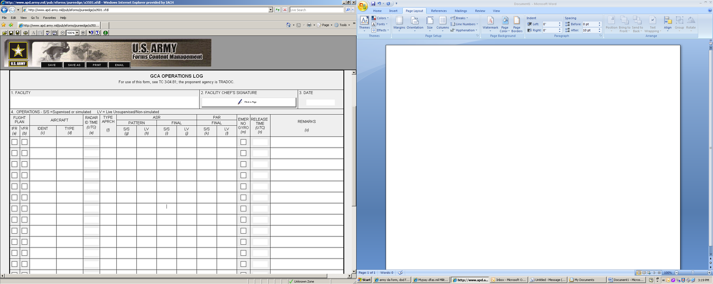

Start here >>>>>

>>>>>>

>>>

>>>

>>

>>

>>

>>

>>

NAME>>





